Jurnal  Teknologi |  |  |  | Full Paper
RSM-assisted Rosemary Essential Oil Precipitation for Elucidating the Interplay of Nanoencapsulation via Rapid Homogenization Dynamics  Phuri Kalnaowakulª, Chatchawan Sookman^{b}, Jittima Kalnaowakul^{c}, Kanchana Luepong^{b}*  ªFaculty of Industry and Technology, Rajamangala University of Technology Isan, Sakon Nakhon 47160, Thailand  ^{b}Faculty of Engineering, Rajamangala University of Technology Krungthep, Bangkok 10120, Thailand  ^{c}Sirindhorn College of Public Health Trang, Trang 92110, Thailand |  |  | Article history  Received  X Month 202Y  Received in revised form  XA Month 202Y  Accepted  XB Month 202Y  *Corresponding author  kanchana.l@mail.rmutk.ac.th
Graphical abstract  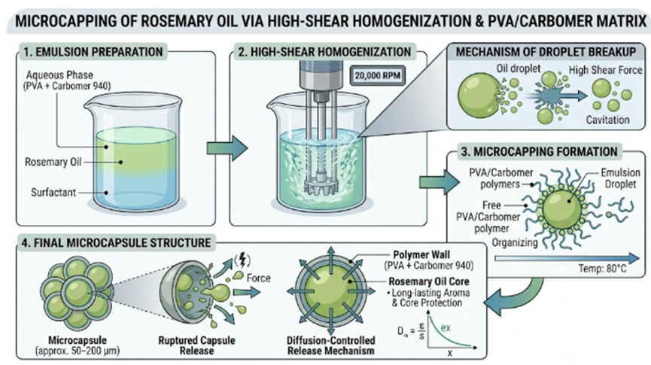 |  | Abstract  Nanotechnology plays a pivotal role in various industrial and clinical applications, including food science, agriculture, and herbal medicine. This study aims to enhance the parameters for rosemary essential oil encapsulation by the solvent evaporation technique. These were used in response surface methodology (RSM) with a design to look at how changing variables like spinning speed, temperature, and concentration of rosemary essential oil (REO) affected the results. To achieve efficiency, adequate encapsulation investigation, such as Fourier transform infrared spectroscopy (FTIR), scanning electron microscopy (SEM), and Thermogravimetric analysis (TGA), was conducted. The effect of various homogenizer speeds on encapsulation efficiency (EE (%)), and REO were studied. The different of homogenizer speeds start from 1,000, 10,000 to 20,000 rpm combined with temperature and REO were presented the highest encapsulation efficiency (EE (%)). The maximum rotating speeds indicated that the EE (%) of REO encapsulated over 90%. SEM demonstrated that, among all components, the REO had the most pronounced spherical morphology. The FTIR spectra showed a suitable intramolecular bond between various parameters and REO. However, nanotechnology process can synergize to provide a robust foundation for industrial-scale production and further development of REO as a medicinal resource.  Keywords: Rosemary, Essential oil, Molecular distillation, Surfactant reagent assisted, homogenizer method.
 |  | © 2026 Penerbit UTM Press. All rights reserved

1.0 INTRODUCTION

Nanotechnology is emerging as a primary influence in the advancement of the food, medical, and pharmaceutical industries. The application of nanoprecipitation composite process in this domain is wholly commendable. The main emphasis is on herbal formulations that enhance the efficacy and extraction of essential oil compounds through nanotechnology, thus enabling the amalgamation of traditional herbal therapy with technological innovations. In this context, the extraction of essential oils (EOs) has long been acknowledged as an intriguing method for the utilization of aromatic plants. Aromatic plant-based nanoparticles possess significant antidepressant and sleep-enhancing potential, as they can mitigate side effects, a frequent consequence of wellness interventions. Non-herbal formulations such as phytosomes, liposomes, capsules, and emulsions were examined to elucidate the mechanism of synergistic herbal essential oils and their application in nano-encapsulation [1, 2, 3]. The herbal industry has been substantially advanced by encapsulation technology, which has facilitated the incorporation and stabilization of aromatic active compounds within a variety of essential oil systems. This method entails the encapsulation of botanical active compounds within a carrier matrix, thereby enhancing their bioavailability, regulatory release, and stability. In order to optimize the health benefits of bioactive compounds, including vitamins, minerals, antioxidants, and probiotics, their effective distribution is necessary. Encapsulation not only protects these substances from harmful environmental conditions and interactions with other dietary constituents but also preserves their functional qualities [4, 5, 6]. The nutritional advantages of herbal active compounds are well-documented, with numerous studies underscoring their significance in health promotion, prevention, and therapy.
Rosemary (Rosmarinus officinalis L.) is a Mediterranean-native aromatic herbal therapy plant. Its potent medicinal properties, which include antioxidant, anti-inflammatory, antimicrobial, antidepressant, and sleep-enhancing effects, have garnered significant attention. Additionally, it functions as a seasoning in cosmetics, beverages, and culinary applications [7, 8, 9]. Rosmarinic acid, flavonoids, terpenoids, carnosic acid, and phenolic acids are the components of rosemary extracts (RE) that are responsible for their antioxidant and antibacterial properties. Rosmanol, rosmarinic acid, carnosol, carnosic acid, and tannin are the primary polyphenolic components present in the RE. The antioxidant and bioactive properties of rosemary are significantly improved by the phenolic components [10, 11, 12, 13]. Polyphenols are highly susceptible to heat and light, which can render them unstable. Additionally, they frequently do not dissolve readily in water, which complicates their utilization by the body. Additionally, the scope of their applicability in pharmaceutical and culinary settings is restricted. Microencapsulation has been identified as a viable approach to resolve these concerns, thereby enhancing the applicability of polyphenols in industrial settings, particularly in functional foods that are designed to provide health benefits [14, 15, 16]. Micro- or nano-encapsulation is a useful way to include delicate parts from rosemary extract into tiny bead forms, which helps make them more available and stable. The success of micro- or nano-encapsulation, how quickly the compounds are released, and the shape of the resulting micro- or nano-capsules (beads) are important features of the final product [17]. The high-speed homogenization technique can be employed to micro- or nano encapsulate the active constituent. Nevertheless, the lengths that were generated following the dispersion process remained micron-sized. Increased stirring velocities do not necessarily lead to significant changes in particle size; however, there is a slight increase in the polydispersity index. These nanoparticles are suitable for the incorporation of active substances, large-scale production, the improvement of product stability, and the omission of the need for organic solvents [18]. However, microencapsulation technologies pose certain obstacles. Elevated production expenses, intricate manufacturing processes, and scalability challenges are prevalent impediments. Moreover, interactions between encapsulated drugs and their surroundings might sometimes reduce efficacy. Resolving these difficulties is essential to enhance the technology and broaden its practical application across various sectors [19]. The development of more effective and efficient delivery systems is facilitated by the enhanced regulation of the release and targeting of bioactive substances that nanoencapsulation provides [20], [21]. These developments have the potential to significantly impact the future of food science, pharmaceuticals, and nutrition by facilitating the development of innovative products that meet the growing demand for health care solutions among consumers [22]. Consequently, the optimization of concentration parameters and data analysis are essential for the enhancement of manufacturing efficiency and the prevention of defects, as well as the extension of the life of encapsulation and the reduction of surfactant activity. In particular, online encapsulation monitoring systems are appealing for optimizing the encapsulation efficiency utilization ratio [23]. In addition to the information generated during the extraction process, a variety of statistical optimization techniques have been investigated and are available for the purpose of optimizing the input variables of absorbing processes. These techniques include Taguchi optimization, Grey relational analysis, Response Surface Methodology (RSM), Signal-to-Noise Ratio (SNR), and Analysis of Variance (ANOVA) [24]. RSM is a compilation of statistical and mathematical techniques that are used to model problems in which a response variable is needed to be optimized and is determined by multiple variables [25]. It has been employed to generate a mathematical model, optimize and analyze the experimental parameters, and provide significantly more information from a limited number of experiments. The utmost or minimum response values and the optimal factor settings (x) that produce the best response (Y) can be determined by examining response surfaces.
By overlaying the contours of the response surfaces of the regression models in a composite plot, the optimal conditions can be determined graphically. The RSM was extensively utilized in numerous research studies to examine the interactivity of independent variables across diverse domains, including analytical chemistry [26, 27, 28] and applied chemistry [29], [30]. Additionally, the stability and integrity of the encapsulated systems were elucidated through the investigation methods, including SEM, TGA, and FTIR, which were used to examine microstructures and morphologies. This study highlights practical applications, showcasing the potential of essential oil as a functional encapsulating medium for sensitive bioactive chemicals such as rosemary extract, advancing beyond previous research through systematic optimization and application-focused analysis.

2.0 METHODOLOGY

2.1 Materials

Carbomer 940, a low-viscosity material from Stongchemicals in Thailand, was used as the exterior material. The fundamental component was an essential oil, specifically Rosemary oil (Krungthepchemi, Thailand). The cross-linking material was composed of Polyvinyl alcohol (PVA, Sigma-Aldrich, USA) and Tween 80 (Chem-Supply, Australia).

2.2 Preparation of emulsion precipitation

The RSM method was created to dissolve PVA concentrations in distilled water, resulting in the preparation of carbomer and REO material solutions, as illustrated in Table 1. The solutions were maintained at ambient temperature overnight to calculate that the polymer molecules were completely hydrated. After that, Tween 80 served as emulsifier, mixed with REO in a 1:1 and 3:1 ratio. The REO solution was introduced at three speed data points for coating ratios of 1000, 10000, and 20000 rpm at 10 min. The REO solution was centrally located, with a layer of carbomer applied in varying amounts as described below.

Table 1 Carbomer and REO ratio prepared by RSM method

Group no. | Speed (rpm) | Temperature (C°) | REO (wt%) | Carbomer (wt%)
I | 1,000 | 40 | 0.50 | 0.50
 |  |  | 2.25 | 0.75
 |  |  | 3.00 | 1.00
II | 10,000 | 40 | 0.50 | 0.50
 |  |  | 2.25 | 0.75
 |  |  | 3.00 | 1.00
III | 20,000 | 40 | 0.50 | 0.50
 |  |  | 2.25 | 0.75
 |  |  | 3.00 | 1.00
IV | 1,000 | 60 | 0.50 | 0.50
 |  |  | 2.25 | 0.75
 |  |  | 3.00 | 1.00

V | 10,000 | 60 | 0.50 | 0.50
 |  |  | 2.25 | 0.75
 |  |  | 3.00 | 1.00
VI | 20,000 | 60 | 0.50 | 0.50
 |  |  | 2.25 | 0.75
 |  |  | 3.00 | 1.00
VII | 1,000 | 80 | 0.50 | 0.50
 |  |  | 2.25 | 0.75
 |  |  | 3.00 | 1.00
VIII | 10,000 | 80 | 0.50 | 0.50
 |  |  | 2.25 | 0.75
 |  |  | 3.00 | 1.00
VIIII | 20,000 | 80 | 0.50 | 0.50
 |  |  | 2.25 | 0.75
 |  |  | 3.00 | 1.00

After this high-aggressively blending, the samples were examined by homogenizer (JSHR-270D, Korea). Subsequently, the sample particles were dried and placed in a humidity chamber as in Figure 1.

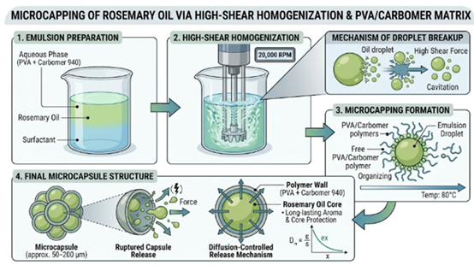

Figure 1 Preparation of REO nano encapsulate formation

2.3 Encapsulation efficiency

The EE (%) is determined to compare the amounts of distilled water constituents before and after encapsulation. 1 g of the microencapsulated substance was initially measured and combined with 100 mL of distilled water to serve as a solvent. Consequently, the UV-visible spectrophotometer (Libra S270, Biochrom USA) was employed to measure the total REO standard at λ_{max} (278 nm), as illustrated in Figure 2. In the same way, the surface REO content of microcapsules was determined by suspending nano-encapsules in distilled water for one minute and measuring the absorbance, as is approximately described in [31, 32, 33]. The following calculation formula was used to determine the EE (%) of nano-encapsules:

EE (%) =
The maximal EE (%) of nano-encapsules was obtained by all experiments that were repeated twice (97.44%), as illustrated in Table 2. The probable explanation is the effective utilization of blending parameters and the compatibility of complex polymers.
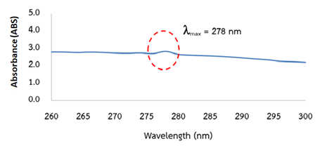

Figure 2 REO standard used by UV-visible photometer

Table 2 the maximum of emulsion concentration, encapsulation yield (EY %), and encapsulation efficiency (EE %) at 80 °C

Run no. | REO (wt%) | Carbomer (wt%) | PVA / Tween 80 (wt%) | EY (%) | EE (%)
1 | 0.5 | 0.5 | 0.25 | 65.26 | 82.02
2 | 0.5 | 0.5 | 0.25 | 65.60 | 82.24
Average |  |  |  | 65.43 | 82.13
3 | 2.25 | 0.75 | 0.25 | 70.15 | 89.42
4 | 2.25 | 0.75 | 0.25 | 70.27 | 89.92
Average |  |  |  | 70.21 | 89.67
5 | 3.00 | 1 | 0.25 | 76.87 | 97.41
6 | 3.00 | 1 | 0.25 | 77.43 | 97.47
Average |  |  |  | 77.15 | 97.44

2.4 Fourier-transformed infrared spectroscopy (FTIR) analysis

The Spectrum FTIR spectrometer (PerkinElmer, USA) was used to analyze the functional groups and provide information on the structural properties of the samples. At a scanning resolution of 1 cm⁻¹, the wavelengths of all spectra are recorded between 4000 and 400 cm⁻¹.

2.5 Thermogravimetric analysis (TGA) details

The thermal stability film of the active oil was analyzed using the TGA instrument (TGA/DSC 3 Plus, Mettler Toledo, Switzerland). Under a nitrogen purge gas flow rate of 20 mL/min, samples weighing 5 mg were heated at a rate of 10°C/min within a temperature range of 25 to 200°C.

2.6 Scanning electron microscopy (SEM) setup

The active films (1 cm × 1 cm) were affixed to a carbon tape on an aluminum holder, and a gold layer was sputter-coated on the top surface. The JSM-IT700HR (JEOL, Japan) was used to observe the surface and cross-sectional micrographs of the active films at an operating voltage of 5.00 kV.

2.7 Statistical data

The functional qualities of affected REO following duplicate, utilizing Minitab software (Minitab, Inc., U.S.A.). All statistical analyses were conducted with a 95% confidence level of significance; p-values less than 0.05 indicate a substantial difference in the data. In order to assess the variability of the data points that were acquired, descriptive and fixed statistics were calculated. The Response Surface Methodology (RSM) was employed to investigate the influence of process parameters on encapsulation efficiency (EE%). Statistical significance was evaluated using Analysis of Variance (ANOVA), where the null hypothesis (H₀) postulated that there were no significant factor effects on encapsulation efficiency. In contrast, the alternative hypothesis (H₁) proposed that there were significant factor influences.

2.8 pH setup

The samples were placed in a controlled environment (25°C ± 1°C, 72% ± 12% relative humidity) for 1 h., to assess the pH. The samples were aseptically transferred to Petri plates and placed in an incubator. The pH levels of the samples were re-evaluated after 1, 3, 5, 7, 9, 11, and 13 days of environmental exposure. For each sample, we measured 0.5 weight percent (wt.%) of REO and diluted it in 10 mL of distilled water. The pH was assessed thrice post-homogenization with a pH meter.

3.0 RESULTS AND DISCUSSION

3.1 The chemical makeup of rosemary essential oil (REO)

The results of the chemical composition analysis of REO are summarized in Table 3. In accordance with Table 3, the primary components of REO are camphor, 1,8-cineole, 3-carene, α-pinene, trans-caryophyllene, and β-pinene. These findings align with established knowledge of the primary chemical constituents of REO as documented in the literature (Ahsaei et al., 2020 [34]; Yeddes et al., 2020 [35]).

Table 3 Chemical constituents of the rosemary essential oil (REO)

Components | Percentage (%)
β-Bisabolene, β-Caryophyllene | 0.30
Lavandula, 3-Keto-isosteviol | 1.13
Fenchone | 1.30
Aromadendrane, Viridiflorol, α-Santalol | 1.80
Acetaldehyde, Camphor, β-pinene | 2.48
δ-Cadinene | 3.40
Cymene, α-pinene | 3.84
Terpineol, Borneol | 4.31
Trans-caryophyllene, Isoborneol | 5.54
γ-Cadinene, Copaene, α-ylangene, Cycloisosativene | 13.97
β-Propiolactone | 14.44
α-Terpinolene, Camphene, 3-Carene | 16.50
1,8-Cineole | 30.91

3.2 SEM of REO encapsulated results

The morphology of the REO microencapsulated was analyzed using SEM images, as shown in Figure 3. The REO encapsules exhibit spherical, oval, and irregular surfaces, which are typical of homogenization encapsules. Reservoirs and matrices constituted the manifestation of the homogenizer encapsulates. The morphology of the encapsulate can be affected by the polymer type employed; nonetheless, spray-dried microcapsules attain equivalent outcomes (Zhu et al., 2021 [36]). During emulsion formation, the crosslinking interactions between Carbomer 940 and Tween 80 polymers established a continuous covering on the oil phase.

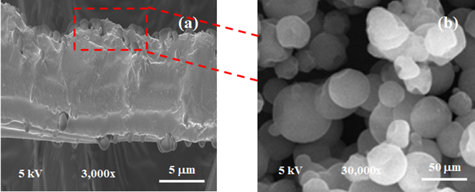

Figure 3 SEM of REO encapsulated at different magnifications: (a) 3,000x and (b) 30,000x

3.3 FTIR spectroscopy results

The spectrum of REO is shown in Figure 4. The molecular-level variation of chemical groups in composites is frequently investigated using FTIR analysis. Terpinolene, 1,8-cineole, and camphene comprise the majority of the components. Several components comprise the overall content, with pinene isomers serving as the primary component. Each of these components contributes to the C–H stretching bands at 1430 cm⁻¹ and 3285-2865 cm⁻¹ (in the functional group region). The ether functionality of the aliphatic polyether epoxy ring of 1,8-cineole is the component for the peaks at 1150 and 927 cm⁻¹. Additionally, the peak at 1028 cm⁻¹ is obtained with the asymmetric elongation of the C-O bond [37]. Nevertheless, the two spectra exhibited some discrepancies, including a minor absorption band at approximately 850-400 cm⁻¹ and a pronounced peak at wavenumbers 1250-1000 cm⁻¹. They are linked to the intermolecular bonds of the functional groups of polysaccharides. These findings are in agreement with the findings of Fatemeh and Saeed et al., 2019 [38].

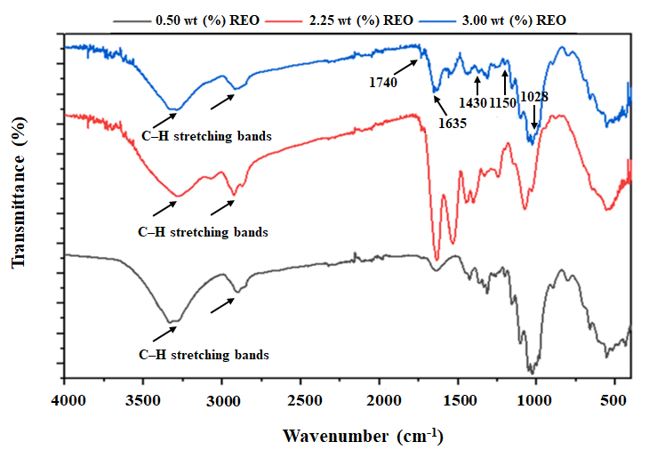
Figure 4 FTIR spectra of REO encapsulated film

3.4 TGA analysis results

The REO encapsule films during heating, TGA, were implemented. Figure 5 illustrates that the weight loss for all films followed a consistent pattern during the heating process, which consisted of two phases. The initial degradation occurred within a temperature range of 30–100 °C, and it was primarily caused by the vaporization of free and loosely bound water in the film. The secondary degradation, which potentially corresponded to the thermal decomposition of the polymer molecular chains and the release of the essential oils, took place between 100 and 200°C. The material undergoes carbonization as its ultimate degradation (Ji et al., 2022 [39]). The thermal stability of the films is improved by the addition of 3 wt% REO composite, as evidenced by the lower mass losses in the second and final stages compared to 0.5 wt% and 2.25 wt% of REO film. This may be attributed to the interaction between REO and polymer, which enables the formation of a more compact network structure within the films (Liu et al., 2023 [40]). In addition, the initial phase commences with the moisture in the exterior component at 100˚C, whilst the subsequent phase is triggered by the water within the encapsulates at temperatures ranging from 100˚C to 200˚C. The initial phase of the nanocomposite film exhibited less mass loss from water evaporation, attributed to the lowered moisture content, as reported by Pan et al. (2024) [41]. The decomposition of the essential oil at elevated temperatures is the primary factor influencing mass loss due to the films that contained essential oils exhibiting a reduced water content in this investigation. Consequently, the TGA profiles underwent substantial modifications during mass loss.

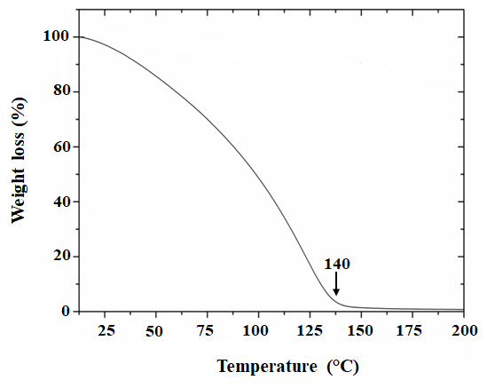
Figure 5 TGA diagram of REO encapsulates

3.5 Response surface optimization of the REO results

The response surface test results were used to derive the final model equation, which allowed for item-by-item testing. The four factors of speed (A), temperature (B), REO (%) (C), and carbomer 940 (%) (D) were fitted with a polynomial to establish a multivariate quadratic regression equation. The equation is as follows: EE (%) = 37.58 + 0.0022A + 10.10C – 0.0005AC. The results indicated that the corresponding T and P-values were used to evaluate the multiple regression analysis and the quadratic model of the response surface for EE (%), as presented in Table 4.
Table 4 RSM effect of the rosemary essential oil (REO)

Term | T-Value | P-Value
A | 3.18 | 0.006
B | 0.07 | 0.943
C | 2.61 | 0.019
D | -0.49 | 0.634
A*A | 0.16 | 0.876
B*B | 0.75 | 0.465
C*C | 0.53 | 0.601
D*D | -0.45 | 0.66
A*B | 1.52 | 0.148
A*C | -2.44 | 0.027
A*D | 0.84 | 0.415
B*C | -0.88 | 0.391
B*D | -1.44 | 0.168
C*D | -0.19 | 0.85

The ANOVA results presented in Table 4 revealed that among the four investigated factors, only two demonstrated statistically significant effects on encapsulation efficiency at α = 0.05:
- Rotational speed (Factor A): T-value = 3.18, p = 0.006 (p < 0.01)
- REO concentration (Factor C): T-value = 2.61, p = 0.019 (p < 0.05)
Conversely, Factor B (T-value = 0.07, p = 0.943) and Factor D (T-value = -0.49, p = 0.634) exhibited no statistically significant influence on the response variable, indicating that these parameters do not substantially affect encapsulation efficiency within the experimental range studied. For the interaction terms evaluated, only the A×C interaction (rotational speed × REO concentration) demonstrated statistical significance (T-value = -2.44, p = 0.027). This negative T-value suggests an antagonistic interaction between these factors, indicating that the combined effect of increased rotational speed and REO concentration is less than the sum of their individual effects. Statistical significance was not achieved for any of the other two-factor interactions (p > 0.05). Figure 6 illustrates that the relationship between significant factors and encapsulation efficiency is predominantly linear within the experimental design space, as indicated by the non-significance of the quadratic terms (A×A, B×B, C×C, D×D).

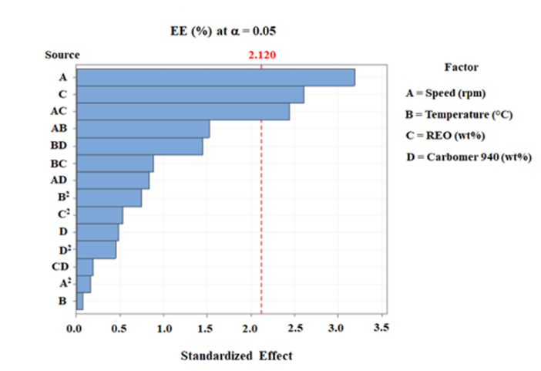
Figure 6 Factor of EE (%) for REO encapsulation

Model adequacy was rigorously validated through residual analysis (Figure 7), encompassing:

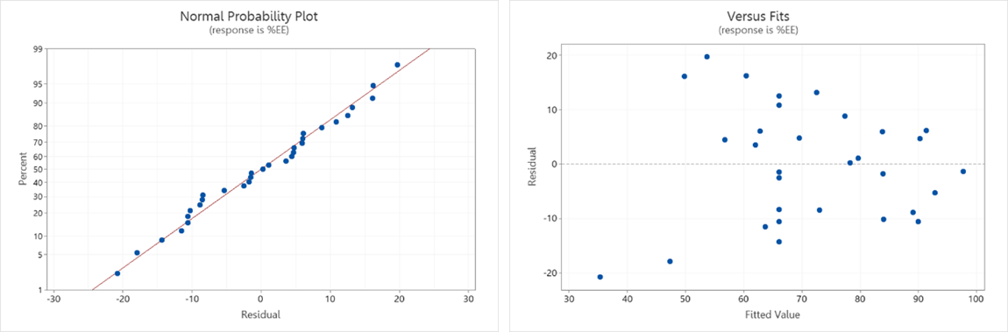

Figure 7 The RSM model supports the reliability of the statistical conclusions from the analysis

Residuals versus Fitted Values Plot:
(1) Normal Probability Plot (Q-Q Plot): The approximately linear arrangement of residuals along the theoretical normal line confirms that the residuals follow a normal distribution, satisfying the normality assumption required for valid statistical inference.
(2) Residuals versus Fitted Values Plot: The random scatter of residuals around zero with constant variance across the range of fitted values indicates homoscedasticity, confirming that the model adequately captures the systematic variation in the data without detectable bias.

3.6 pH analysis results

The pH values exhibited minimal change, as seen in Figure 8. To ascertain the balanced activity of REO emulsions, we assessed them at different concentrations. The presence of REO did not influence pH readings at different concentrations during the 13-day study period. The initial pH of the REO emulsions was around 5.85, as observed. In a previous study by Qin et al., 2024 [42], a trend was observed that initially declined and subsequently rose as the duration of storage increased. The first reduction in pH results from the breakdown of ATP within the REO shell, which increases the concentrations of carbomer 940 and Tween 80. In accordance with Ran et al., 2024 [43], the pH was elevated. The pH levels of the different REO groups had significantly increased by the conclusion of the five-day incubation period, reaching a value of 6. Nevertheless, the pH value of the 5.85 group exhibited the slightest average increase trend, which was 5.60 on the 14th day (P < 0.05). These findings suggest that the REO film exhibited efficient preservation capabilities by preventing the formation of evaporation processes.

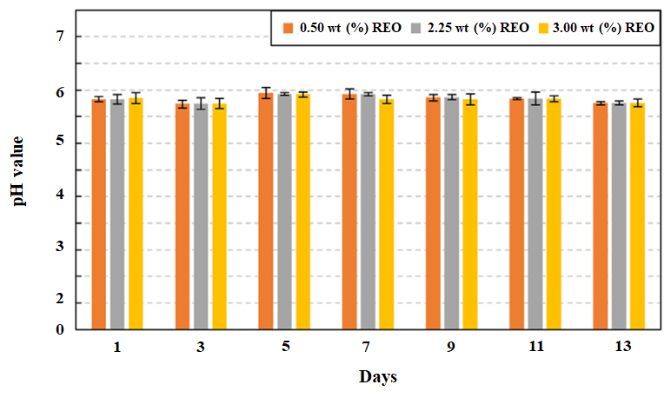
Figure 8 pH test of REO samples on different days

4.0 CONCLUSION

This study successfully fabricated REO encapsulates and integrated with a polymer matrix. SEM analysis confirmed that the film exhibited spherical, oval, and irregular surfaces, while pH test showed that the addition of composite REO did not alter the pH values at various concentrations. TGA and FTIR release, corroborate that homogenizer encapsulation process is optimal at 80˚C and it does not cause loss of oil. The concentration of the cross-linking agents, Carbomer 940 and Tween 80, is essential for the creation of the film or shell. The use of a solution and homogenization resulted in somewhat large encapsulations. The intended use dictates the suitability of REO encapsulates. The identification of REO concentration as the sole significant factor, along with its antagonistic interaction, provides critical insights for process optimization. The non-significance of quadratic effects suggests that optimization can be effectively achieved through linear modelling approaches within the studied experimental domain, potentially simplifying subsequent optimization procedures. The R² values were not reported as this investigation focused solely on factor significance determination rather than predictive model development for response optimization.

Acknowledgement

This research is fully supported by Rajamangala University of Technology Krungthep with Contract no. F1-2567-1008. Additionally, we would like to express our deepest thanks to the Faculty of Industry and Technology, Rajamangala University of Technology Isan, and Sirindhorn College of Public Health Trang, which gave us opportunities to carry out the investigations in this study, which is greatly appreciated. Finally, Center of Excellent in Chemical Engineering Analytical and Instrumentation, and the Research and Development Institute of Rajamangala University of Technology Krungthep were instrumental in facilitating the successful completion of this work.
References

- Dias, M.I., Ferreira, I.C.F.R., and Barreiro, M.F. 2015. Microencapsulation of Bioactives for Food Applications. Food Function. 6: 1035–1052.
- Onwulata, C.I. 2013. Microencapsulation and Functional Bioactive Foods. J. Food Process. Preserv. 37: 510–532.
- Liu, J., Lai, R., Wang, X., Wang, H., and Liu, Y. 2020. Preparation and Characterization of Composites of Hydroxypropyl Tapioca Starch and Zein. Starch – Stärke. 72: 1900204.
- Huang, K., Yuan, Y., and Baojun, X. A. 2023. Critical Review on the Microencapsulation of Bioactive Compounds and Their Application. Food Rev. Int. 39: 2594–2634.
- Sousa, V.I., Parente, J.F., Marques, J.F., Forte, M.A., and Tavares, C.J. 2022. Microencapsulation of Essential Oils: A Review. Polymer. 14: 1730.
- Niizawa, I., Espinaco, B.Y., Zorrilla, S.E., and Sihufe, G.A. 2019. Natural Astaxanthin Encapsulation: Use of Response Surface Methodology for the Design of Alginate Beads. Int. J. Biol. Macromol. 121: 601–608.
- Sánchez-Camargo, A.d.P., and Herrero, M. 2017. Rosemary (Rosmarinus Officinalis) as a Functional Ingredient: Recent Scientific Evidence. Curr. Opin. Food Sci. 14: 13–19.
- Visentin, A., Rodríguez-Rojo, S., Navarrete, A., Maestri, D., and Cocero, M.J. 2012. Precipitation and Encapsulation of Rosemary Antioxidants by Supercritical Antisolvent Processes. J. Food Eng. 109: 9–15.
- Kanakidi, L.-D., Tsimogiannis, D., Kiokias, S., and Oreopoulou, V. 2022. Formulation of Rosemary Extracts through Spray-Drying Encapsulation or Emulsification. Nutraceuticals. 2: 1–21.
- Alkhatib, H., Doolaanea, A.A., Assadpour, E., Mohmad Sabere, A.S., Mohamed, F., and Jafari, S.M. 2022. Optimizing the Encapsulation of Black Seed Oil into Alginate Beads by Ionic Gelation. J. Food Eng. 328: 111065.
- Gaikwad, N.N., Kalal, A.Y., Suryavanshi, S.K., Patil, P.G., Sharma, D., and Sharma, J. 2021. Process Optimization by Response Surface Methodology for Microencapsulation of Pomegranate Seed Oil. J. Food Process. Preserv. 45: 15561.
- Tolun, A., Altintas, Z., and Artik, N. 2016. Microencapsulation of Grape Polyphenols Using Maltodextrin and Gum Arabic as Two Alternative Coating Materials: Development and Characterization. J. Biotechnol. 239: 23–33.
- Wang, H., Ma, Y., Liu, L., Liu, Y., and Niu, X. 2022. Incorporation of clove essential oil nanoemulsion in chitosan coating to control Burkholderia gladioli and improve post-harvest quality of fresh Tremella fuciformis. LWT. 1770: 114059.
[14] Wang, F., Wei, F., Song, C., Jiang, B., Tian, S., Yi, J., Yu, C., Song, Z., Sun, L., and Bao, Y. 2017. Dodartia Orientalis L. Essential oil exerts antibacterial activity by mechanisms of disrupting cell structure and resisting biofilm. Ind. Crops Prod. 109: 358–366.
[15] Ju, J., Chen, X., Xie, Y., Yu, H., Guo, Y., Cheng, Y., Qian, H., Yao, W. 2019. Application of essential oil as a sustained-release preparation in food packaging. Trends Food Sci. Tech. 92: 22–32.

[16] Bhavaniramya, S., Vishnupriya, S., Al-Aboody, M.S., Vijayakumar, R., and Baskaran, D. 2019. Role of essential oils in food safety: Antimicrobial and antioxidant applications. Grain Oil Sci. Technol. 2: 49–55.
[17] Ramdhan, T., Ching, S. H., Prakash, S., and Bhandari, B. 2022. Evaluation of alginate biopolymer (protein, hydrocolloid, and starch) composite microgels prepared by the spray aerosol technique as a carrier for green tea polyphenols. Food Chemistry. 371: 131382.
[18] Meher, J. G., Yadav, N.P., Sahu, J.J., and Sinha, P. 2013. Determination of required hydrophilic lipophilic balance of citronella oil and development of stable cream formulation. Drug Development and Industrial Pharmacy. 39: 1540–1546.
[19] Hashim, N. A., Mudalip, S.K.A., Man, R.C., and Sulaiman, S. Z. 2023. Menhaden fish oil encapsulation by spray drying process: Influence of different biopolymer materials, inlet air temperature, and emulsion ratios. Journal of Chemical Technology and Biotechnology. 98: 2726–2733.
[20] Kłosowska, A., Wawrzynczak, A., and FeliczakGuzik, A. 2023. Microencapsulation as a route for obtaining encapsulated flavors and fragrances. Cosmetics. 10: 1–18.
[21] Lopez, A., Castro, S., Andina, M.J., Ures, X., Munguía, B., Llabot, J.M., Elder, H., Dellacassa, E., Palma, S., and Domínguez, L. 2014. Insecticidal activity of microencapsulated Schinus molle essential oil. Ind. Crops Prod. 53: 209–216.
[22] Li, S., Boyter, J., and Qian, L. 2005. UV curing for encapsulated aroma finish on cotton. J. Text. Inst. 96: 407–411.
[23] Jafari, S.M., Assadpoor, E., Bhandari, B., and He, Y. 2008. Nano-particle encapsulation of fish oil by spray drying. Food Res. Int. 41: 172–183.
[24] Chemat, F., Abert-Vian, M., Fabiano-Tixier, A.S., Strube, J., Uhlenbrock, L., Gunjevic, V., and Cravotto, G. 2019. Green Extraction of Natural Products. Origins, Current Status, and Future Challenges. TrAC—Trends Anal. Chem. 118: 248–263.
[25] Hemmati, V., Garavand, F., Goudarzi, M., Sarlak, Z., Cacciotti, I., & Tiwari, B. K. 2021. Cold atmospheric-pressure plasma treatment of turmeric powder: Microbial load, essential oil profile, bioactivity, and microstructure analyses. Int. J. Food Sci. & Technol. 56(5): 2224–2232.
[26] Goncalves, G.G., Mancinelli, R.C., and De Morais, L.A.S. 2009. Influence of cutting time on the yield of basil and rosemary essential oil. Horticultura Brasileira. 27(2): 108–112.
[27] Fernandes, R.V.B., Guimarães, I.C., Ferreira, C.L.R., Botrel, D.A., Borges, S.V., and De Souza, A.U. 2017. Microencapsulated rosemary (Rosmarinus officinalis) essential oil as a bio preservative in minus frescal cheese. J. Food Process. Preserv. 41(1): 12759.
[28] Das, S., Singh, V.K., Dwivedy, A.K., Chaudhari, A.K., and Dubey, N.K. 2021. Exploration of some potential bioactive essential oil components as green food preservatives. LWT. 137: 110498.
[29] Bousbia, N., Abert Vian, M., Ferhat, M. A., Petitcolas, E., Meklati, B. Y., and Chemat, F. 2009. Comparison of two isolation methods for essential oil from rosemary leaves: Hydrodistillation and microwave hydrodiffusion and gravity. Food Chemistry. 114(1): 355–362.
[30] Satyal, P., Jones, T., Lopez, E., McFeeters, R., Ali, N., Mansi, I., Al-kaf, A., and Setzer, W. 2017. Chemotypic characterization and biological activity of Rosmarinus officinalis. Foods. 6: 20.
[31] Yilmazer, M., Goksu Karagoz, S., Ozkan, G., and Karacabey, E. 2016. Aroma transition from rosemary leaves during aromatization of olive oil. J. Food Drug Anal. 24: 299–304.
[32] Martins, E., Poncelet, D., and Renard, D. 2017. A novel method of oil encapsulation in coreshell alginate microcapsules by dispersion-inverse gelation technique. React. Funct. Polym. 114: 49–57.
[33] Martín, A., Varona, S., Navarrete, A., and Cocero, M.J. 2014. Encapsulation and coprecipitation processes with supercritical fluids: applications with essential oils. Open Chem. Eng. J. 4: 31–41.
[34] Ahsaei, S.M., Rodríguez-Rojo, S., Salgado, M., Cocero, M.J., Talebi-Jahromi, K., and Amoabediny, G. 2020. Insecticidal activity of spray-dried microencapsulated essential oils of Rosmarinus officinalis and Zataria multiflora against Tribolium confusum. Crop Prot. 128: 104996.
[35] Yeddes, W., Djebali, K., Aidi Wannes, W., Horchani-Naifer, K., Hammami, M., Younes, I., and Saidani Tounsi, M. 2020. Gelatin-chitosan-pectin films incorporated with rosemary essential oil: optimized formulation using mixture design and response surface methodology. Int. J. Biol. Macromol. 154: 92–103.
[36] Zhu, Y., Li, C., Cui, H., and Lin, L. 2021. Encapsulation strategies to enhance the antibacterial properties of essential oils in food systems. Food Control. 123: 107856.
[37] Stramarkou, M., Oikonomopoulou, V., Missirli, T., Thanassoulia, I., and Krokida, M. 2020. Encapsulation of rosemary essential oil into biodegradable polymers for application in crop management. Journal of Polymers and the Environment. 28: 2161–2177.
[38] Fatemeh, S., & Saeed, S.S. 2019. Effects of encapsulated black caraway extract and sesame oil on kolompeh quality. Foods and Raw Materials. 7: 311–320.
[39] Ji, M., Li, J., Li, F., Wang, X., Man, J., Li, J., and Peng, S. 2022. A biodegradable chitosan-based composite film reinforced by ramie fibre and lignin for food packaging. Carbohydrate Polymers. 281.
[40] Liu, J., Wang, Y., Liu, Y., Shao, S., Zheng, X., and Tang, K. 2023. Synergistic effect of nano-zinc oxide and tea tree essential oil on the properties of soluble soybean polysaccharide films. International Journal of Biological Macromolecules. 239.
[41] Pan, Z., Zhong, W., Xu, J., Li, D., Lin, J., Wu, W., and Wu, C. 2024. Effects of oregano essential oil Pickering emulsion and ZnO nanoparticles on the properties and antibacterial activity of konjac glucomannan/carboxymethyl chitosan nanocomposite films. RSC Advances. 14(10): 6548-6556.
[42] Qin, C., Li, Z., Zhang, J., Meng, H., Zhu, C. 2024. Preparation, physicochemical properties, antioxidant, and antibacterial activities of quaternized hawthorn pectin films incorporated with thyme essential oil. Food Packaging and Shelf Life. 41: 101235.
[43] Ran, C., Li, Q., Zhao, M., Cui, H., Yang, Y., Diao, K., and Wang, Q. 2024. Gelatin/polyvinyl alcohol films loaded with doubly stabilized clove essential oil chitosomes: Preparation, characterization, and application in packing marinated steaks. Food Chemistry. 460, 140673.

